Homework 01

Zhicheng Zhang

Practice 1-1

The case description shows that Starlight DVD and Games Rentals (SDGR for short) already has a rental tracking system. The system may contain following information of each DVD / game disk.

* object identifier
* title
* rental status: available, rented, etc.
* returned date

Based on new requirements provided by the case description, it is clear that the aforementioned system has to be updated. However, upgrading an existing system has several risks:

* It might be difficult to understand the old system because documents might be lost.
* There might be some implicit bugs in the old system. These bugs might appear when modifying something.
* Dozens of business data has been stored in the old system. Modifying may cause unexcepted data loss.

Because of these, **rebuild the whole system (start with a new model) is a good choice.** Only new created data (new DVD, new game disk, new bills) will be stored and processed in the new system. Previous data in the old system should be converted and migrated to the new system step-by-step.

Logic data model, relational model and data type model are necessary for creating a new database system. Process model and data type model are necessary for creating a new application. Top-down modeling approach is appropriated for a brand-new project like this.

Practice 2-1

|  |  |  |  |  |  |
| --- | --- | --- | --- | --- | --- |
| **Note** | **Business Objective** | **Key Performance Indicator** | **Critical Success Factor** | **Assumption** | **Problem** |
| Store clerks do not know when a membership is due for renewal, and cannot, therefore, proactively encourage customers to renew their membership. |  |  |  |  | Yes |
| To reduce the number of non-returned DVDs from 5% to <1% | Yes |  |  |  |  |
| Staff needs to be alerted when a DVD is more than two weeks overdue. |  |  | Yes |  |  |
| Store clerks cannot easily identify DVDs that are seriously overdue (more than two weeks late). |  |  |  |  | Yes |
| To increase rentals by 25% annually through the introduction of membership privileges | Yes |  |  |  |  |
| Our current system uses Oracle Database 9i and is on UNIX. |  |  |  | Yes |  |
| The number of seriously overdue DVDs should be <3%. |  | Yes |  |  |  |
| Starlight must stock a very wide range of DVDs and sufficient copies of the latest DVDs to ensure that membership is attractive. |  |  | Yes |  |  |
| Store clerks are unable to chase overdue DVDs. |  |  |  |  | Yes |
| Starlight would like to upgrade to Oracle Database 11g on Linux. |  |  |  | Yes |  |

Practice 3-1

(Same as practice 4-1)

Practice 4-1

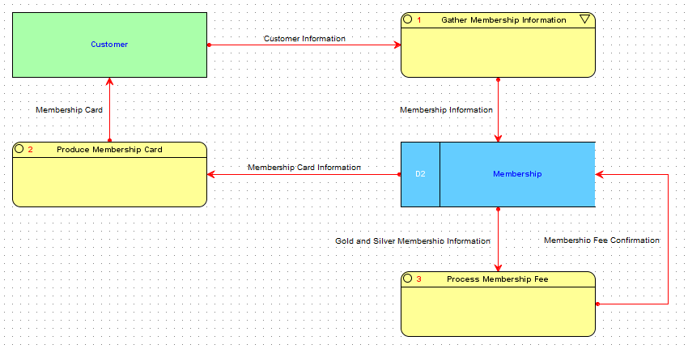

Practice 5-1

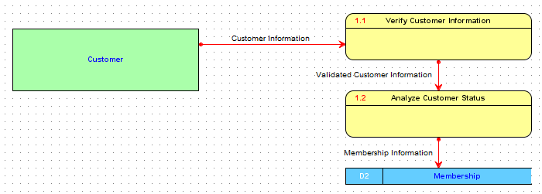

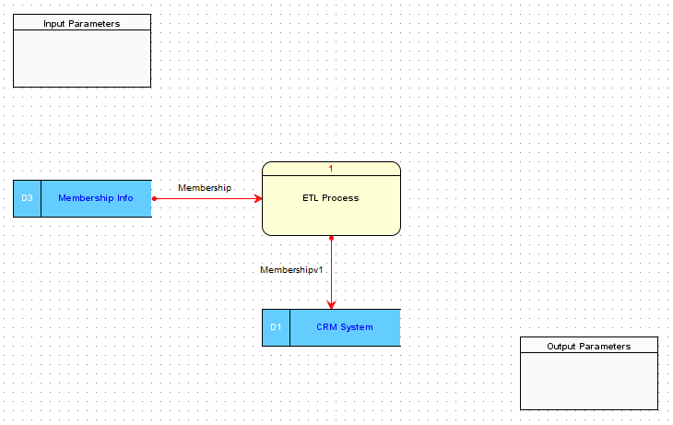

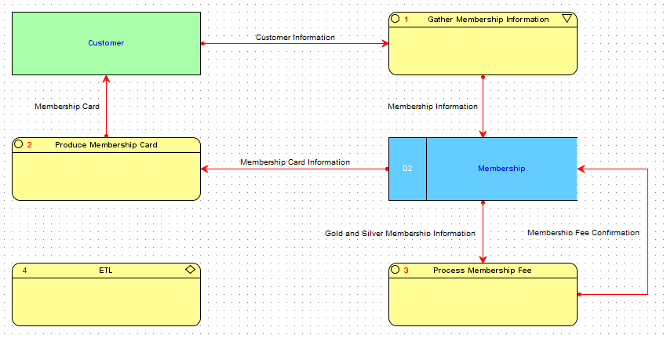

Practice 6-1

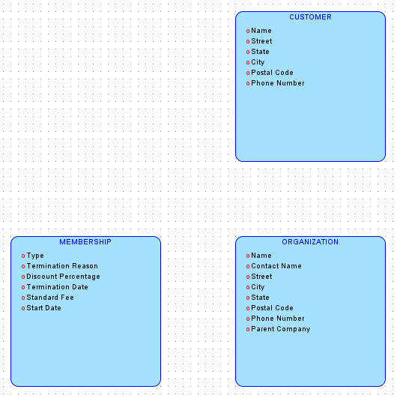

Practice 6-2

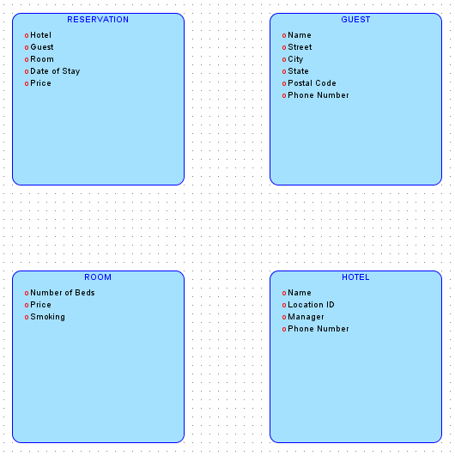

Practice 7-1

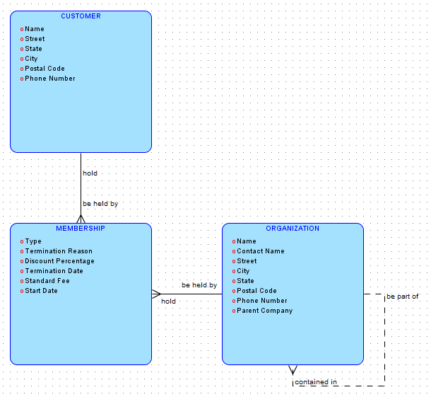

Practice 7-2

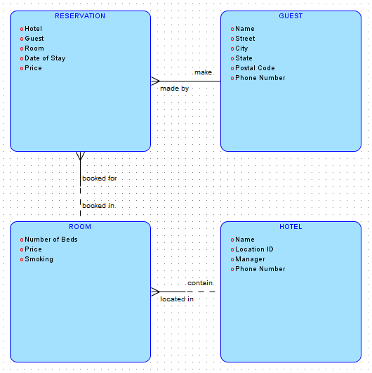

Practice 8-1

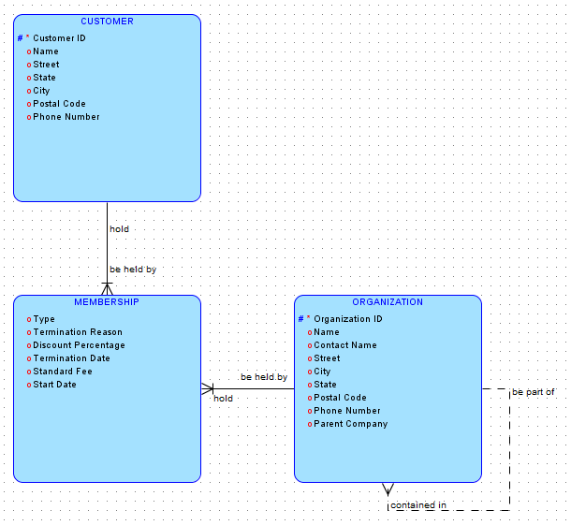

Practice 8-2

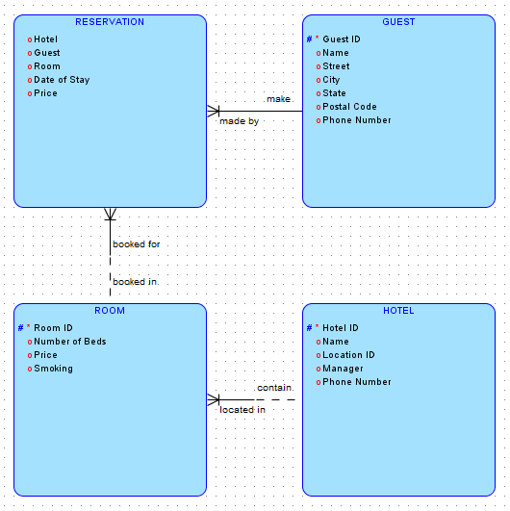

Practice 9-1

(“Hotel scenario” and “DVD membership scenario” are in practice 8 below.)

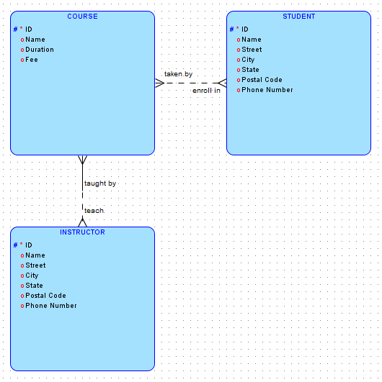

Practice 10-1

